Здесь нам предлагается убрать подзаголовки, т.к. они дублируют названия таблиц, плюс Тим поправил подписи к рисункам и таблицам.

Geranium Instant Report

## Instant Report for PAC 10.

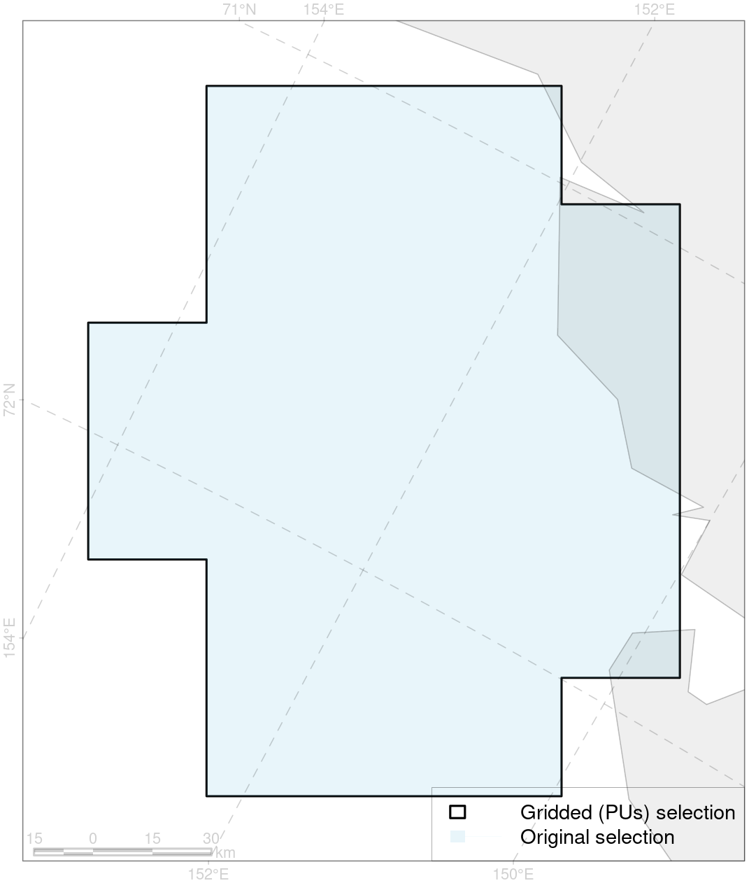

Figure 1: Selected Area

Table 1: Basic statistics of selected area

| No of Pus | No of CFs | Total Area, km2 | Total Area, PUs, km2 | Terrestrial Area, PUs, km2 | Marine Area, PUs, km2 |
| --- | --- | --- | --- | --- | --- |
| 24 | 9 | 21436.04 | 21600 | 1700.1 | 19899.9 |

Table 2: Concern Indexes

| SR, % | MNSR, % | SA, % | MNSA, % |
| --- | --- | --- | --- |
| 276.9 | 251.1 | 42.2 | 44.7 |

Table 3: Conservation Action Prioritisation Indexes

| CAPR, % | CAP, % | AAR, % |
| --- | --- | --- |
| 0 | N/A | 0 |

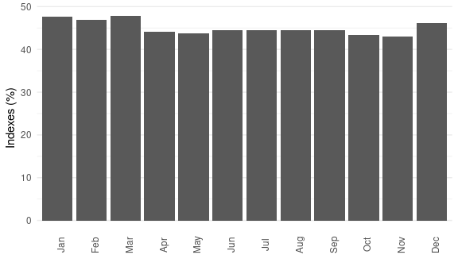

Figure 2: Concern index, by Month – можно ли сохранять цвета на этой диаграмме?

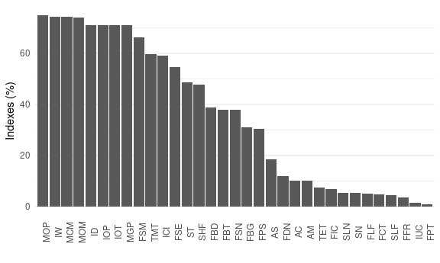

Figure 3: Concern Level by Activity

Table 4: List of Activities ranked by Concern Level by Activity

| Activity ID | Industrial Activity | MNSA, % |
| --- | --- | --- |
| MOP | Oil Production (off-shore) | 75.0 |
| IW | Offshore Wind Farms | 74.4 |
| MCM | Coastal On-Shore Mining | 74.3 |
| MOM | Mining Other (Offshore) | 74.2 |
| ID | Dredging | 71.1 |
| IOP | Underwater Oil & Gas Pipelines | 71.1 |
| IOT | Coastal Oil Terminals (including other petrochemical storing facilities) | 71.1 |
| MGP | Gas Production (Offshore) | 71.1 |
| FSM | Seaweed Mowing | 66.1 |
| TMT | Mass tourism | 59.7 |
| ICI | Coastal Infrastructure (except oil & gas infrastructure) | 59.1 |
| FSE | Seine and Stationary Seine | 54.7 |
| ST | Tankers carrying oil and other petrochemicals | 48.6 |
| SHF | Cargo/Passenger Vessels using HFO | 47.9 |
| FBD | Bottom Dredging | 38.9 |
| FBT | Bottom Trawling | 38.0 |
| FSN | Snurrevad | 38.0 |
| FBG | Bottom Gillnets | 31.0 |
| FPS | Purse Seiner | 30.4 |
| AS | Seaweed Farming | 18.4 |
| FDN | Drift Nets | 12.0 |
| AC | Fish Farms (salmon, cod or other fish species) | 10.0 |
| AM | Shellfish Farms (Mussels, Oysters, scallops etc) | 10.0 |
| TET | Ecotourism | 7.4 |
| FIC | Invertebrates Collection by Divers | 6.9 |
| SLN | Cargo/Passenger LNG-powered Vessels | 5.2 |
| SN | Nuclear-powered Vessels | 5.2 |
| FLF | Longline Fishing | 5.0 |
| FCT | Crab Traps | 4.7 |
| SLF | Cargo/Passenger Vessels using LFO | 4.4 |
| FFR | Fishing Rods | 3.7 |
| IUC | Submarine Communication and Power Cables | 1.4 |
| FPT | Pelagic Trawling | 1.0 |

Table 5: CF list by Concern Level

| CF ID | CF Name | MNSCF, % |
| --- | --- | --- |
| 8035 | Biological communities, salt marshes, East-Siberian Sea | 82.0 |
| 8028 | Biological communities, intertidal zone, East-Siberian Sea | 76.9 |
| 8019 | Biological communities, estuaries, East-Siberian Sea | 63.0 |
| 2009 | Bearded seal (*Erignatus barbatus*) whelping grounds, East-Siberian Sea | 26.5 |
| 4092 | Brackish water fish complex, Indigirka-Kolyma rivers esuaries | 10.6 |
| 4014 | Siberian whitefish (*Coregonus pidschian*) feeding grounds | 5.4 |
| 4010 | Muksun (*Coregonus muksun*) feeding grounds | 5.1 |
| 7103 | Benthic communities, II.1.1.12. East-Siberian Sea shelf coastal domain | 1.0 |
| 7104 | Benthic communities, II.1.1.13. East-Siberian Sea inner shelf | 1.0 |

Table 6: Top CFs by Coverage (showing only those above 20%)

| CF ID | CF Name | Coverage, % | MNSCF, % |
| --- | --- | --- | --- |
| 8028 | Biological communities, intertidal zone, East-Siberian Sea | 48.6 | 76.9 |